[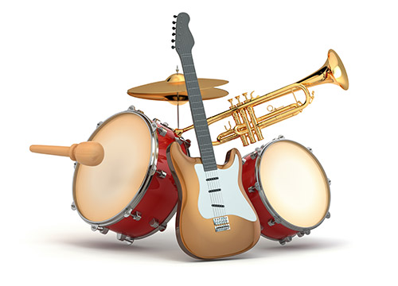](https://www.google.com/url?sa=i&rct=j&q=&esrc=s&source=images&cd=&cad=rja&uact=8&ved=0ahUKEwi_n4iw4M7QAhXC1CYKHSsUBU0QjRwIBw&url=https://www.airserbia.com/en/musical-instruments&bvm=bv.139782543,d.eWE&psig=AFQjCNGV5nOv8ukhj6tvZ7ijPJ43P9yh0A&ust=1480535947352097)[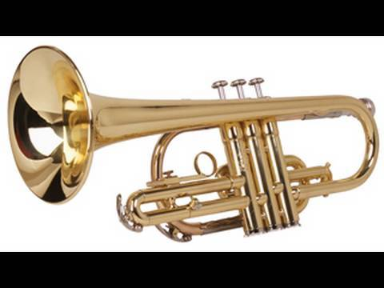](https://www.google.com/url?sa=i&rct=j&q=&esrc=s&source=images&cd=&cad=rja&uact=8&ved=0ahUKEwjKyM3N4M7QAhVLQiYKHSDrCCsQjRwIBw&url=https://www.youtube.com/watch?v%3DVM6o-ziHiAo&bvm=bv.139782543,d.eWE&psig=AFQjCNGV5nOv8ukhj6tvZ7ijPJ43P9yh0A&ust=1480535947352097)